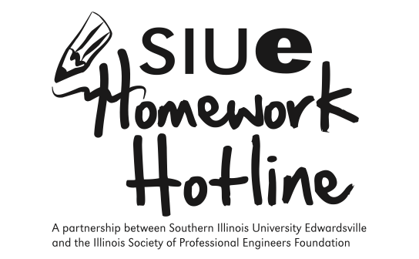

Get FREE Help with Your Math Homework! Your brain will be glad you did.

Students in grades 5-8 can call in and ask math homework questions. It’s FREE!

Tutors are SIUE college students who are trained to help with math homework.

Call 618-650-3072
6-10 p.m.
Sunday - Thursday
September 18, 2016 – April 28, 2017

Rose Hulman Institute of Technology-Founding Partner and Copyright Owner of the Homework Hotline

